Experiment No 4: Set up Wireless Access Point

PART A

(PART A: TO BE REFFERED BY STUDENTS)

A.1 Aim: Set up and configuration of Wireless Access Point.

A.2 Objectives: After successful completion of this experiment students will be able to Set up and configure access point and use it to access internet.

A.3 Outcomes: Student will be able to implement security algorithms for mobile communication network.

A.4 Tools Used/programming language: Cicso Packet Tracer

A.5 Theory:
Access point is a device used to connect Wireless LAN with internet. Access point is used in wireless LAN which might be having standard either IEEE standard or HIPERLAN. It will also be called as router since it works in network layer. Wireless LAN means each computer/laptop connected with each other wirelessly. There are two kinds of LAN possible I) adhoc wireless and ii) infrastructure based Access point configuration is done in such way that it is able to transfer and receive all packets of LAN securely if firewall is installed in that AP.

Access point is will be used here is wifi (D LINK) shown in diagram1 In diagram it is shown that DSL pin where DSL connection will be done where as other port will be used to connect any desktop computer. Following diagram2 will give idea about how access point is seen in wireless LAN Diagram 1
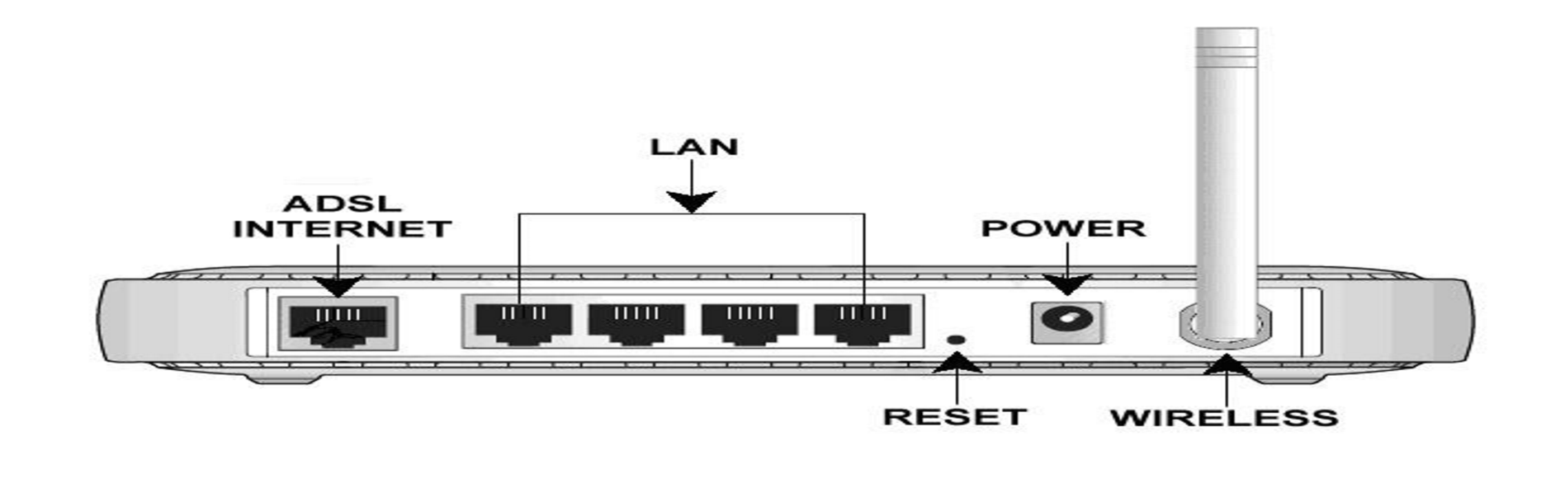

Note: Configuration of AP requires physical connection with internet via ADSL port then start WIFI then Update parameters of AP as per user requirement such as password /LAN name by visiting WIFI router page via internet explorer.
- Wireless Access Point (WAP): A wireless access point (WAP) is a networking hardware device that allows wireless devices to connect to a wired network using Wi-Fi, or related standards. The AP usually connects to a router (via a wired network) as a standalone device, but it can also be an integral component of the router itself. An AP is differentiated from a hotspot, which is the physical space where the wireless service is provided.

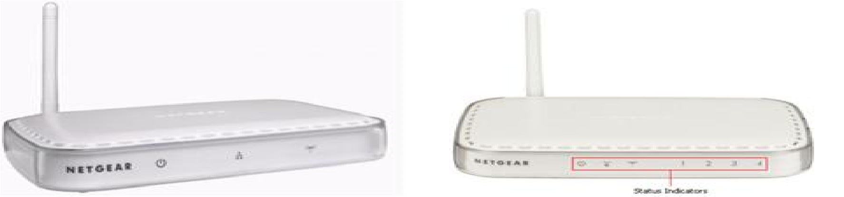

- Steps for configuration of WAP:
- Connect the DSL port of the NETGEAR modem router to the phone line, via the DSL Micro filter, as shown in the diagram. Use an Ethernet cable to connect the computer to any of the four LAN ports as shown in the diagram. Connect the NETGEAR DSL modem router to its power supply unit (PSU) (Not shown in the diagram) and wait about a minute for it to boot up.
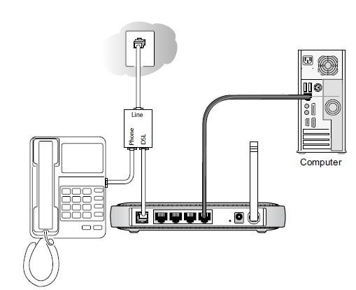
- Open an Internet Explorer browser and type the router IP address which would be either http://192.168.0.1 or http://192.168.1.1 in the address bar and press Enter. o The Login window will prompt for the router configuration username and password.
- The default username is admin and the default password is password o The username and password are case sensitive.
- If the default username and password is not working, you might have changed the password. Please try other passwords that you might have changed to. Otherwise, a factory reset is needed to restore the router to factory defaults. To perform a factory reset, see Restoring a NETGEAR home router to the factory default settings.

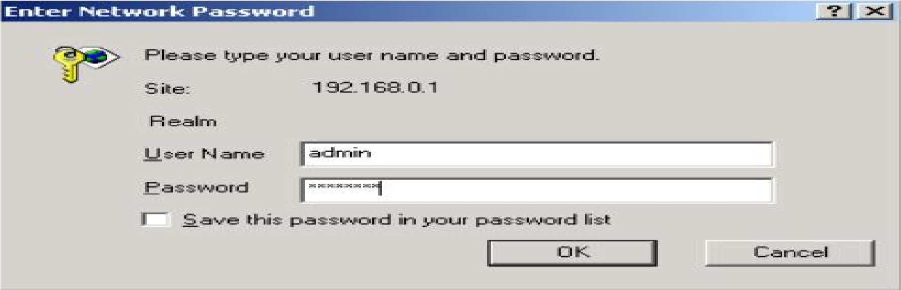
- Click Setup Wizard on the top left corner, Select Yes for the Setup Wizard to detect the type of Internet connection and click Next.

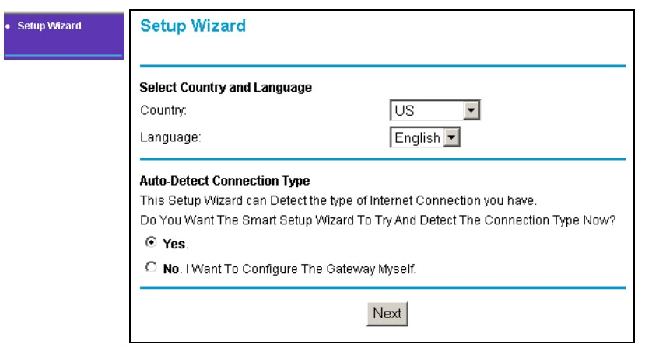

- The Setup Wizard will report which connection type it has discovered, and then display the appropriate configuration page. Please follow the steps under the connection type detected by your router:
Note: If the Setup Wizard finds no connection, please check the physical connection of your devices, and make sure that your ISP has already activated your DSL account.
Wizard Detected PPPoE Login Account Setup
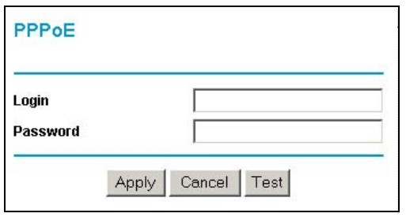
Enter the PPPoE login user name and password. These fields are case sensitive. This information should have been provided to you by your ISP.
Wizard Detected Dynamic IP Account Setup
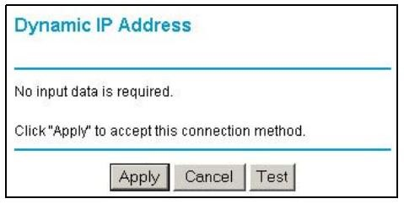
Click Apply to set Dynamic IP as the connection method.
Wizard Detected IP over ATM Account Setup
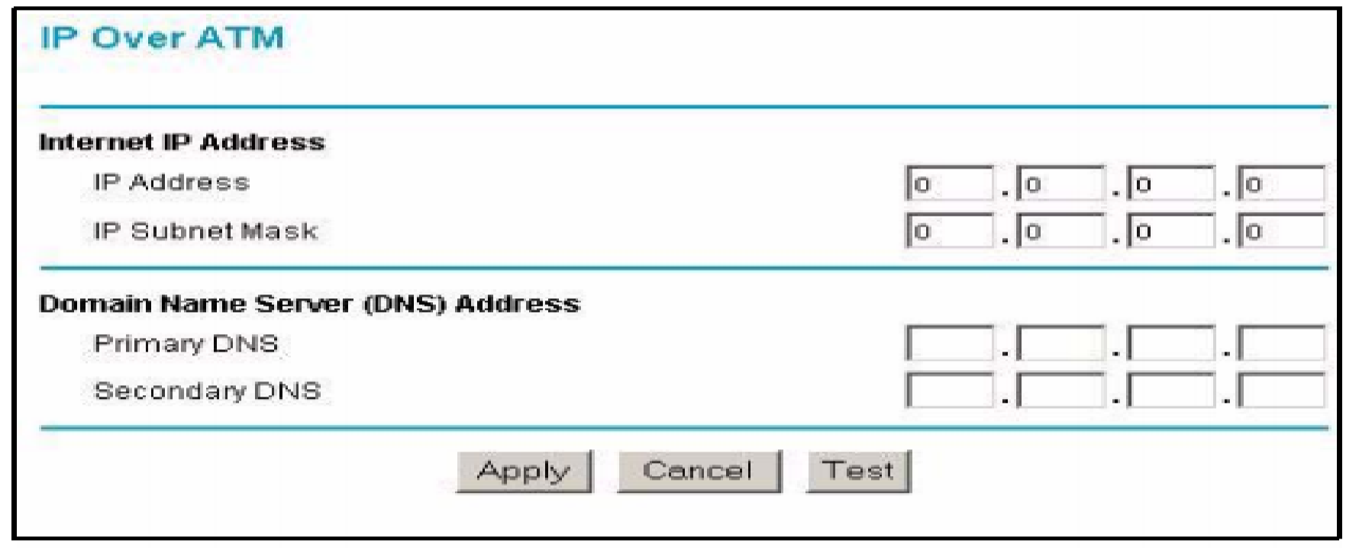
5.
  - Enter your assigned IP Address and Subnet Mask. This information should have been provided to you by your ISP.
  - Enter the IP address of your ISP's Primary DNS Server. If a Secondary DNS Server address is available, enter it also.
  - Click Apply to save the settings.
  - Click Test to test your internet connection.

- Wizard Detected Fixed IP (Static) Account Setup
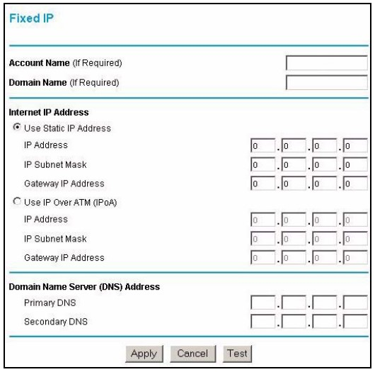
  - If required, enter the Account Name and Domain Name from your ISP.
  - Choose Use Static IP Address or Use IP Over ATM (IPoA-RFC1483 Routed) according
to the information from your ISP.
If you choose IPoA, the router will be able to detect the gateway IP address but you still need to provide the router IP address.
  - Enter your assigned IP Address, Subnet Mask, and the IP Address of your ISP's gateway router.
This information should have been provided to you by your ISP.
  - Enter the IP address of your ISP's Primary DNS Server. If a Secondary DNS Server address is available, enter it also. 5. Click Apply to save the settings.
6. Click Test to test your internet connection.

- The router will now save these settings. When complete, you can verify whether you are connected to the internet from the Router Status under Maintenance menu.

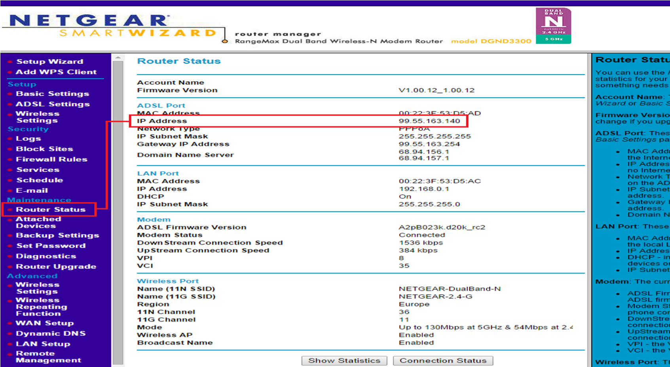

Verify that you have a valid IP address (not blank or 0.0.0.0) on the Internet or ADSL Port.
- Procedure on Cisco tracer: Download Cisco tracer from https://www.netacad.com/courses/packet-tracer.
- Watch you tube video for WI router configuration in Cisco tracer: https://www.youtube.com/watch?v=vu0najkh9vQ

PART B

(PART B: TO BE COMPLETED BY STUDENTS)
(Students must submit the soft copy as per following segments within two hours of the practical. The soft copy must be uploaded on the ERP or emailed to the concerned lab in charge faculties at the end of the practical in case the there is no ERP access available)
Roll No. C54 | Name: Quazi Md Moinuddin
Class : TE-C | Batch : C3
Date of Experiment: 2-2-25 | Date of Submission:24-2-25
Grade :

B.1 Question of Curiosity:

Q.1: Create small Wires less network using WAP. (attach all screenshots)
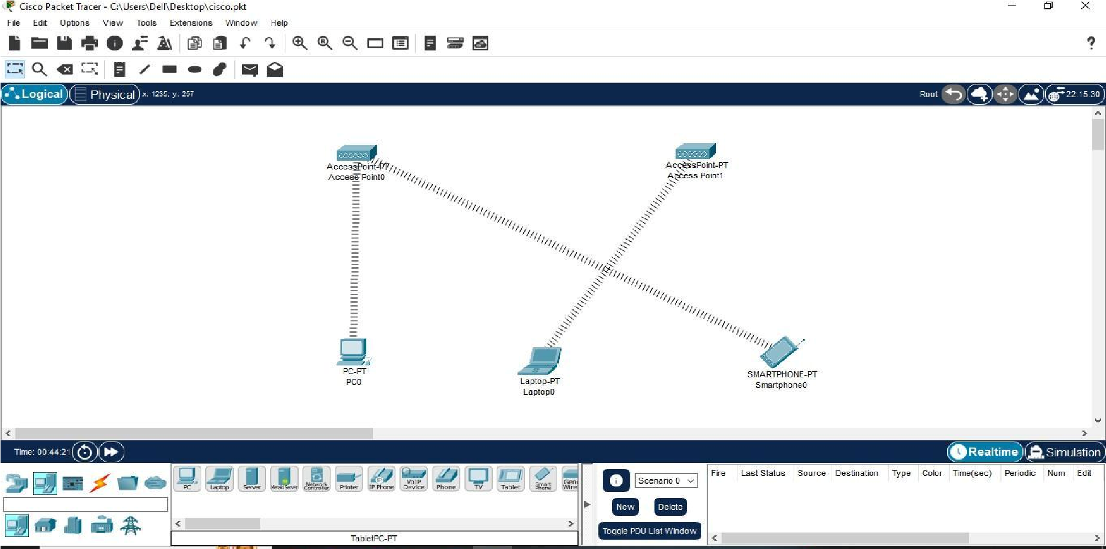
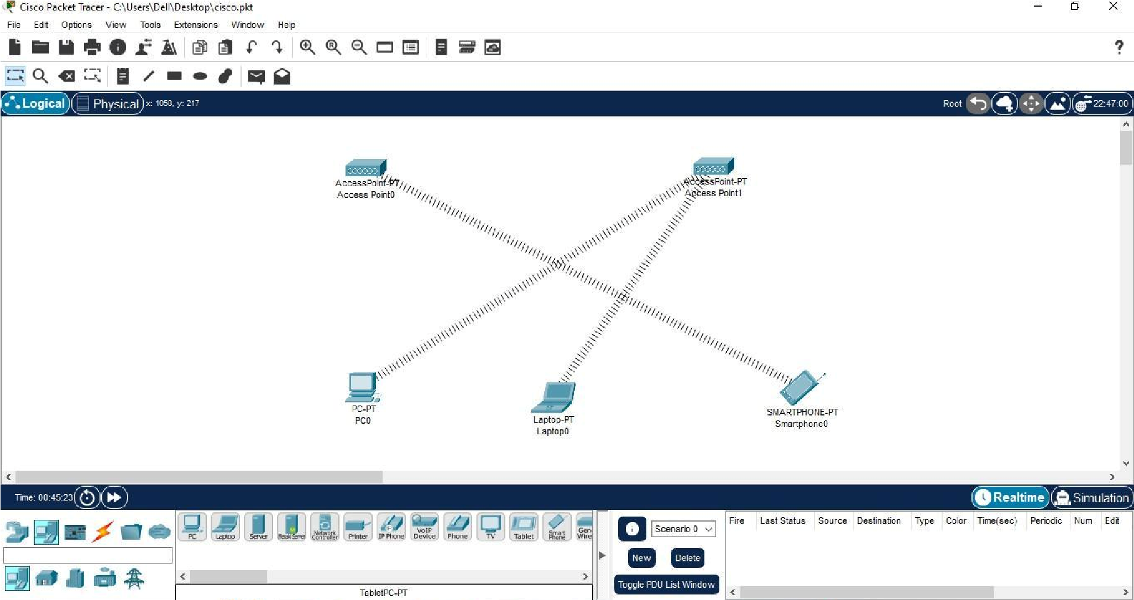
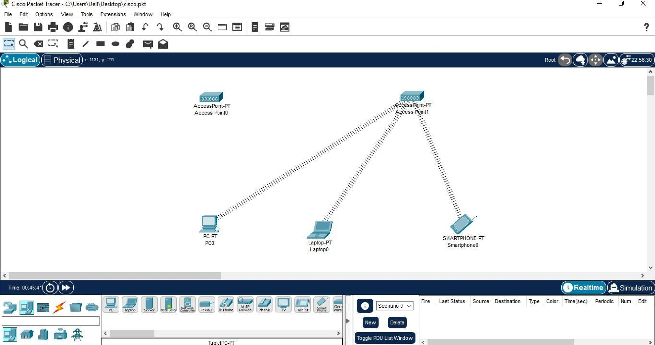
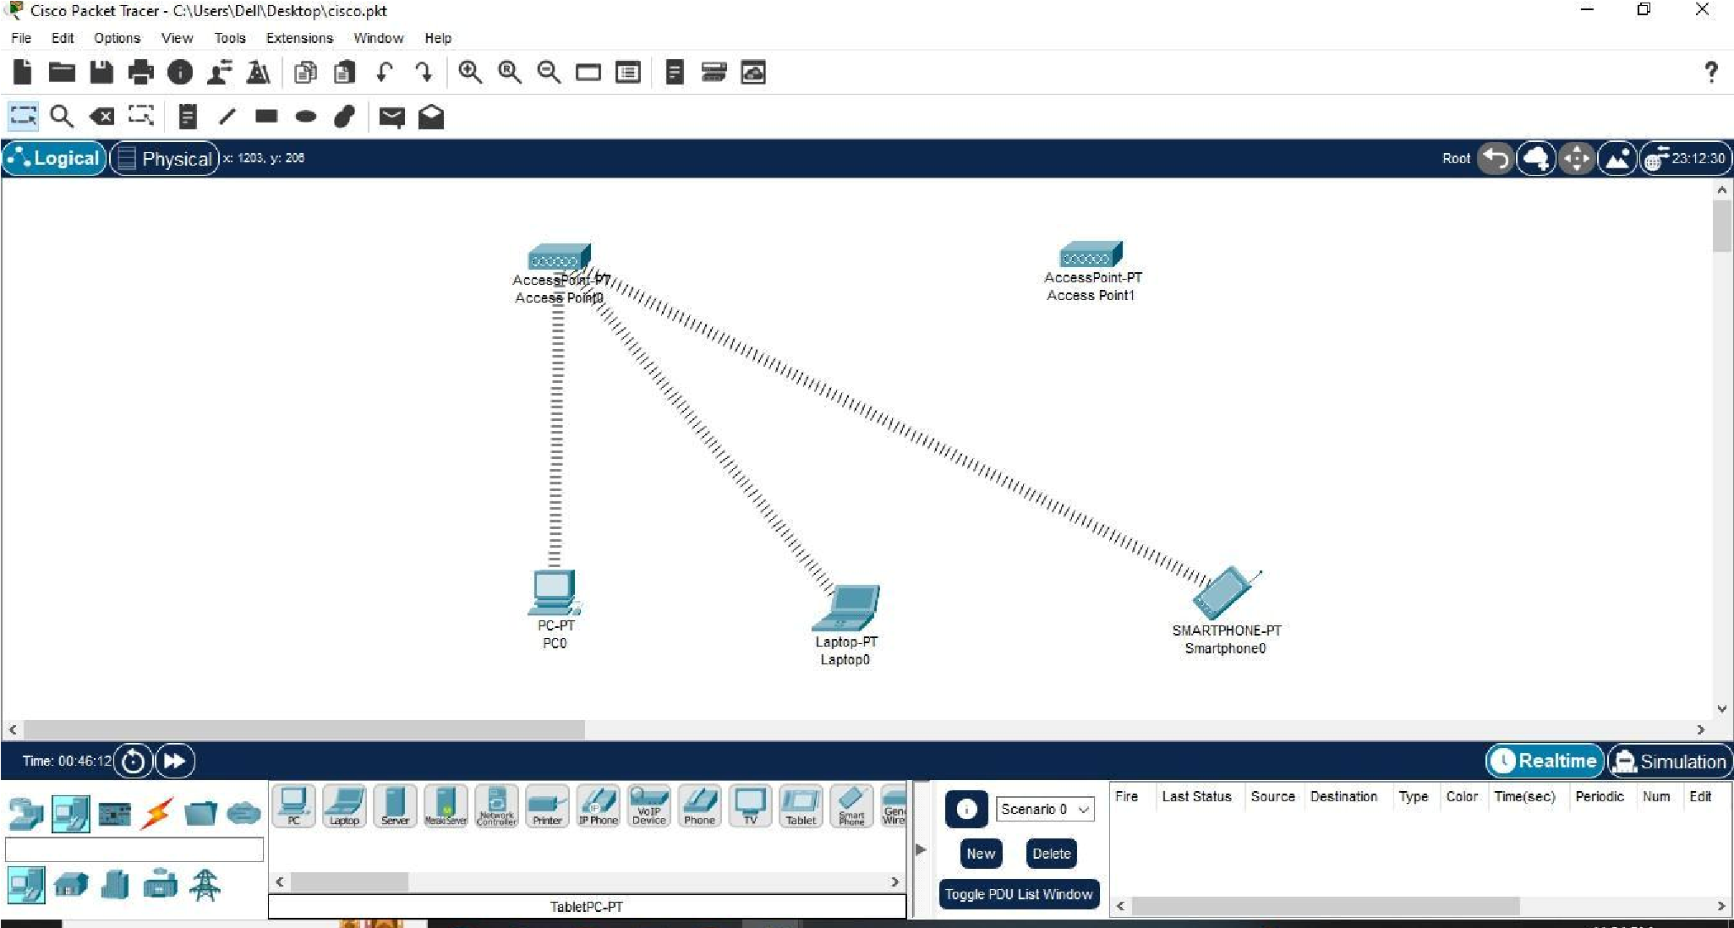
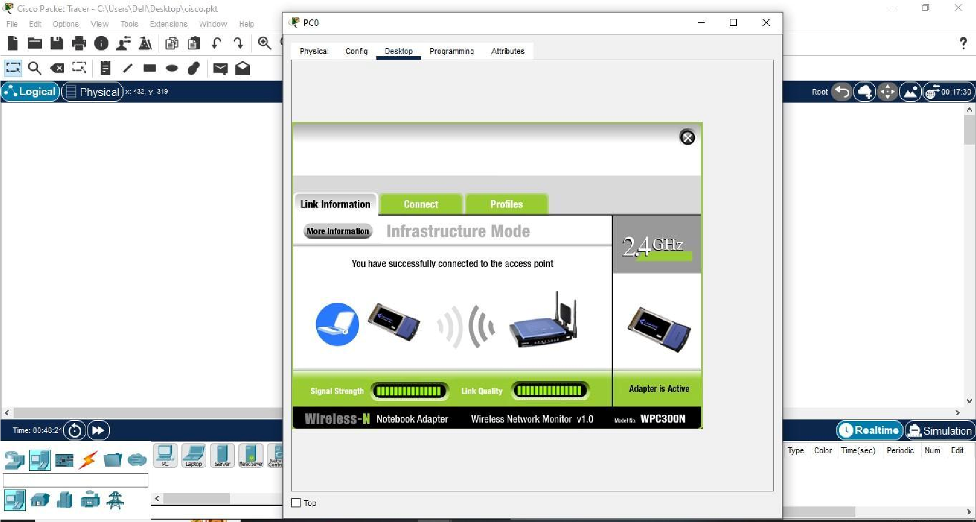
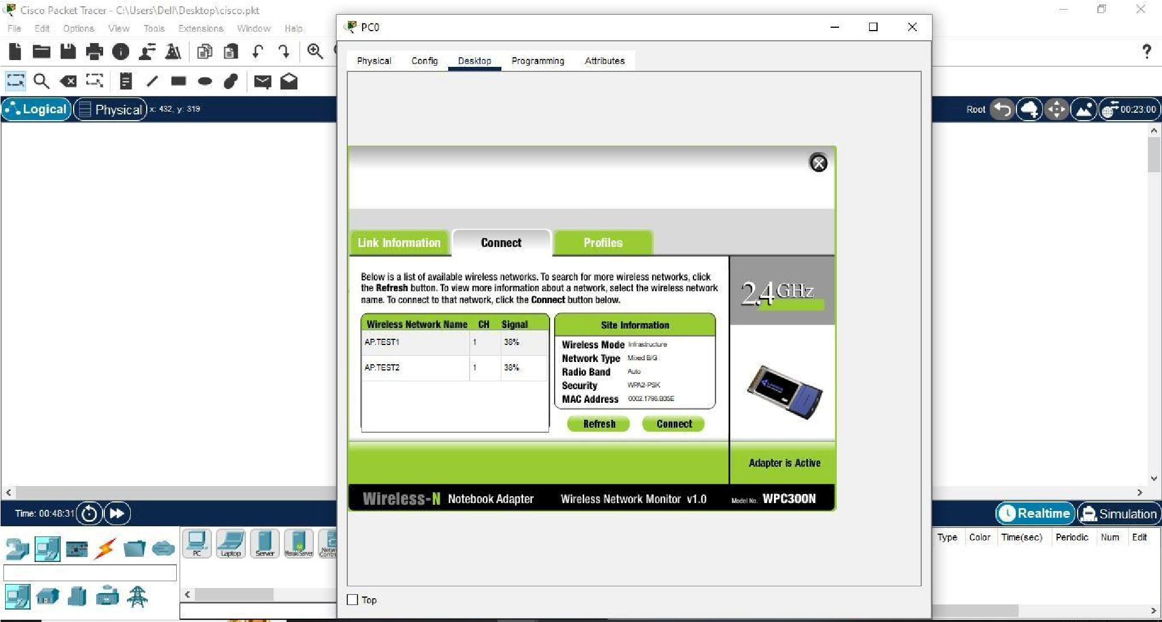
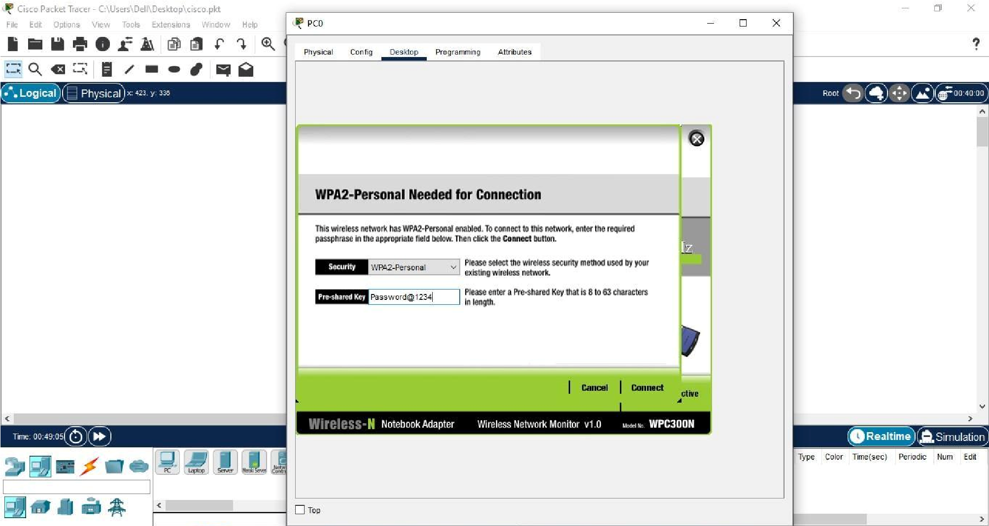
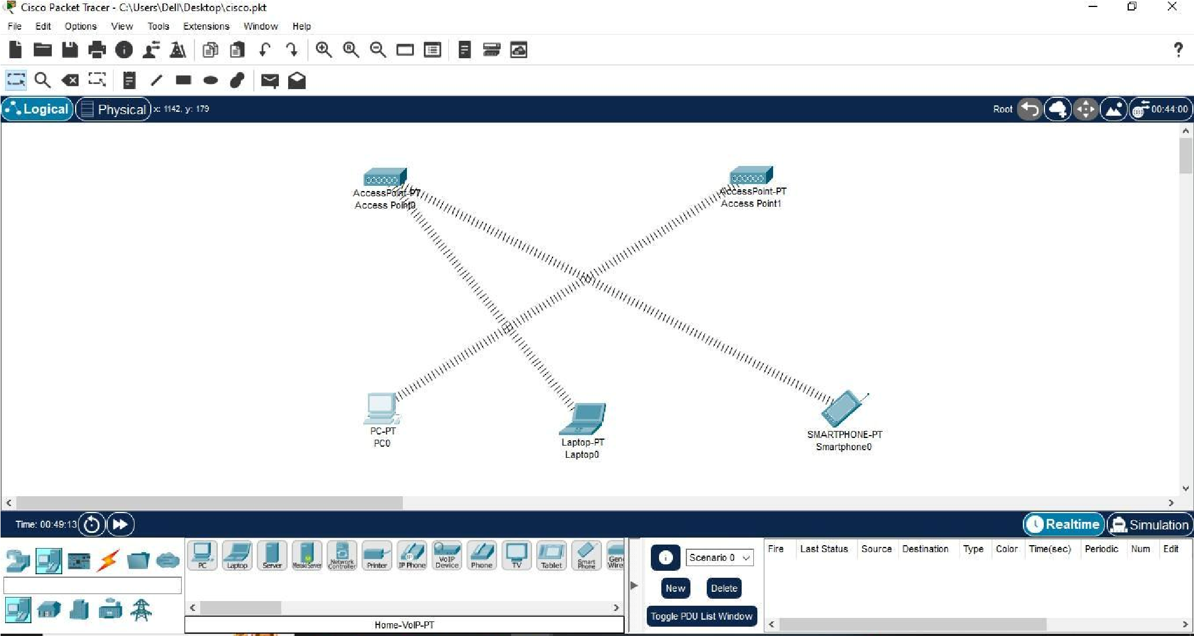
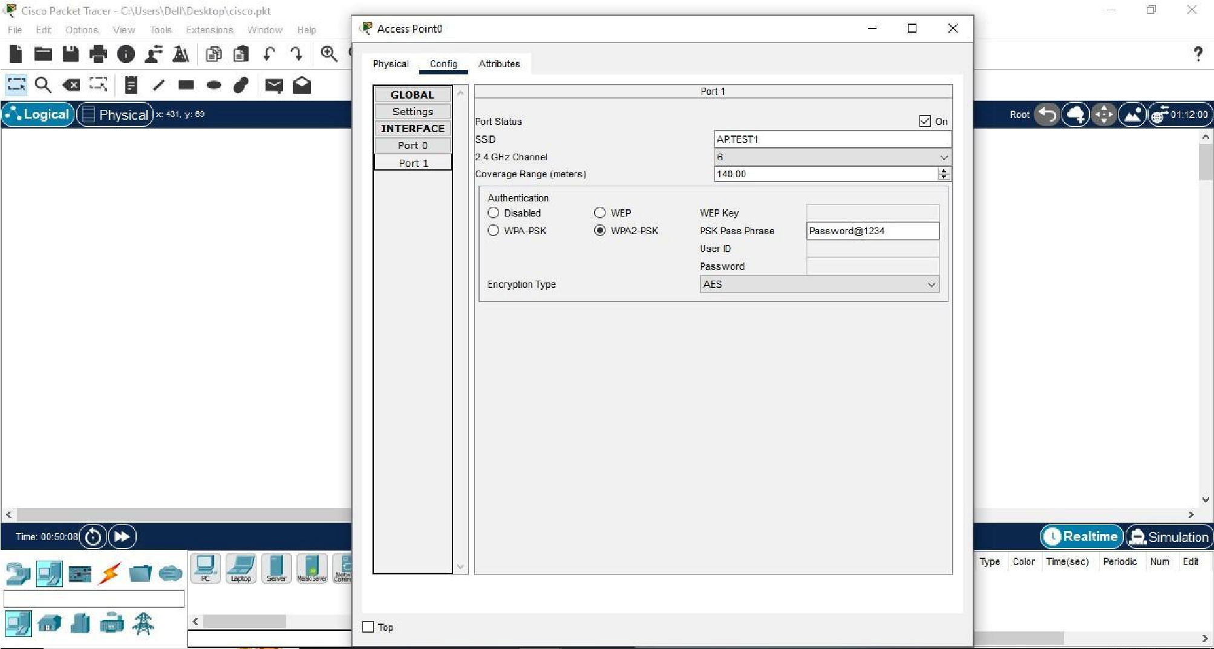
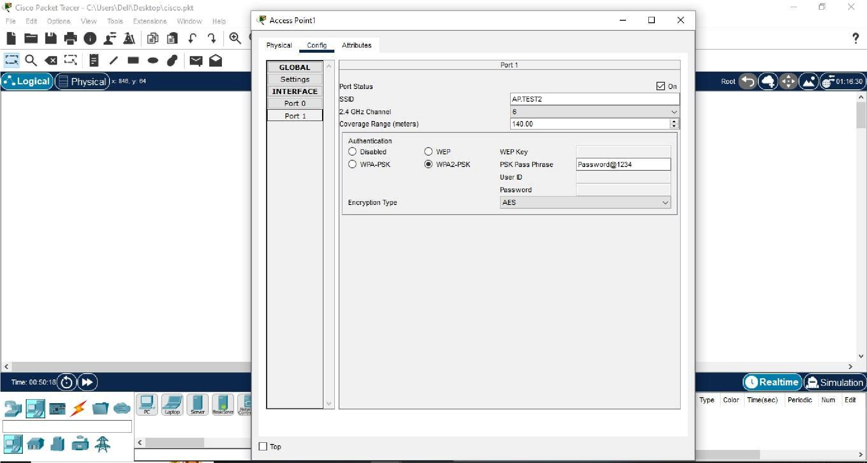
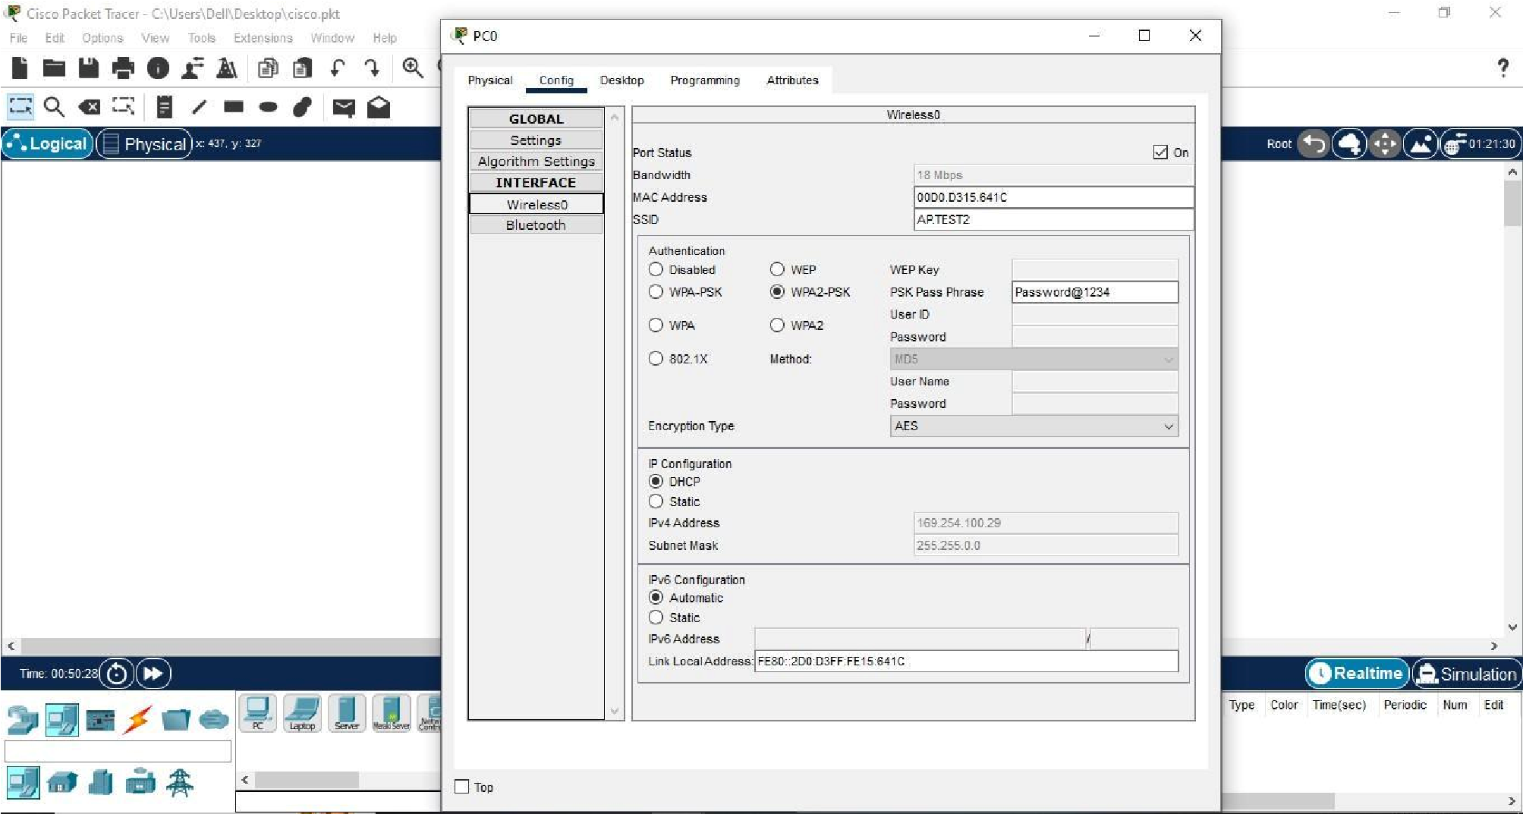
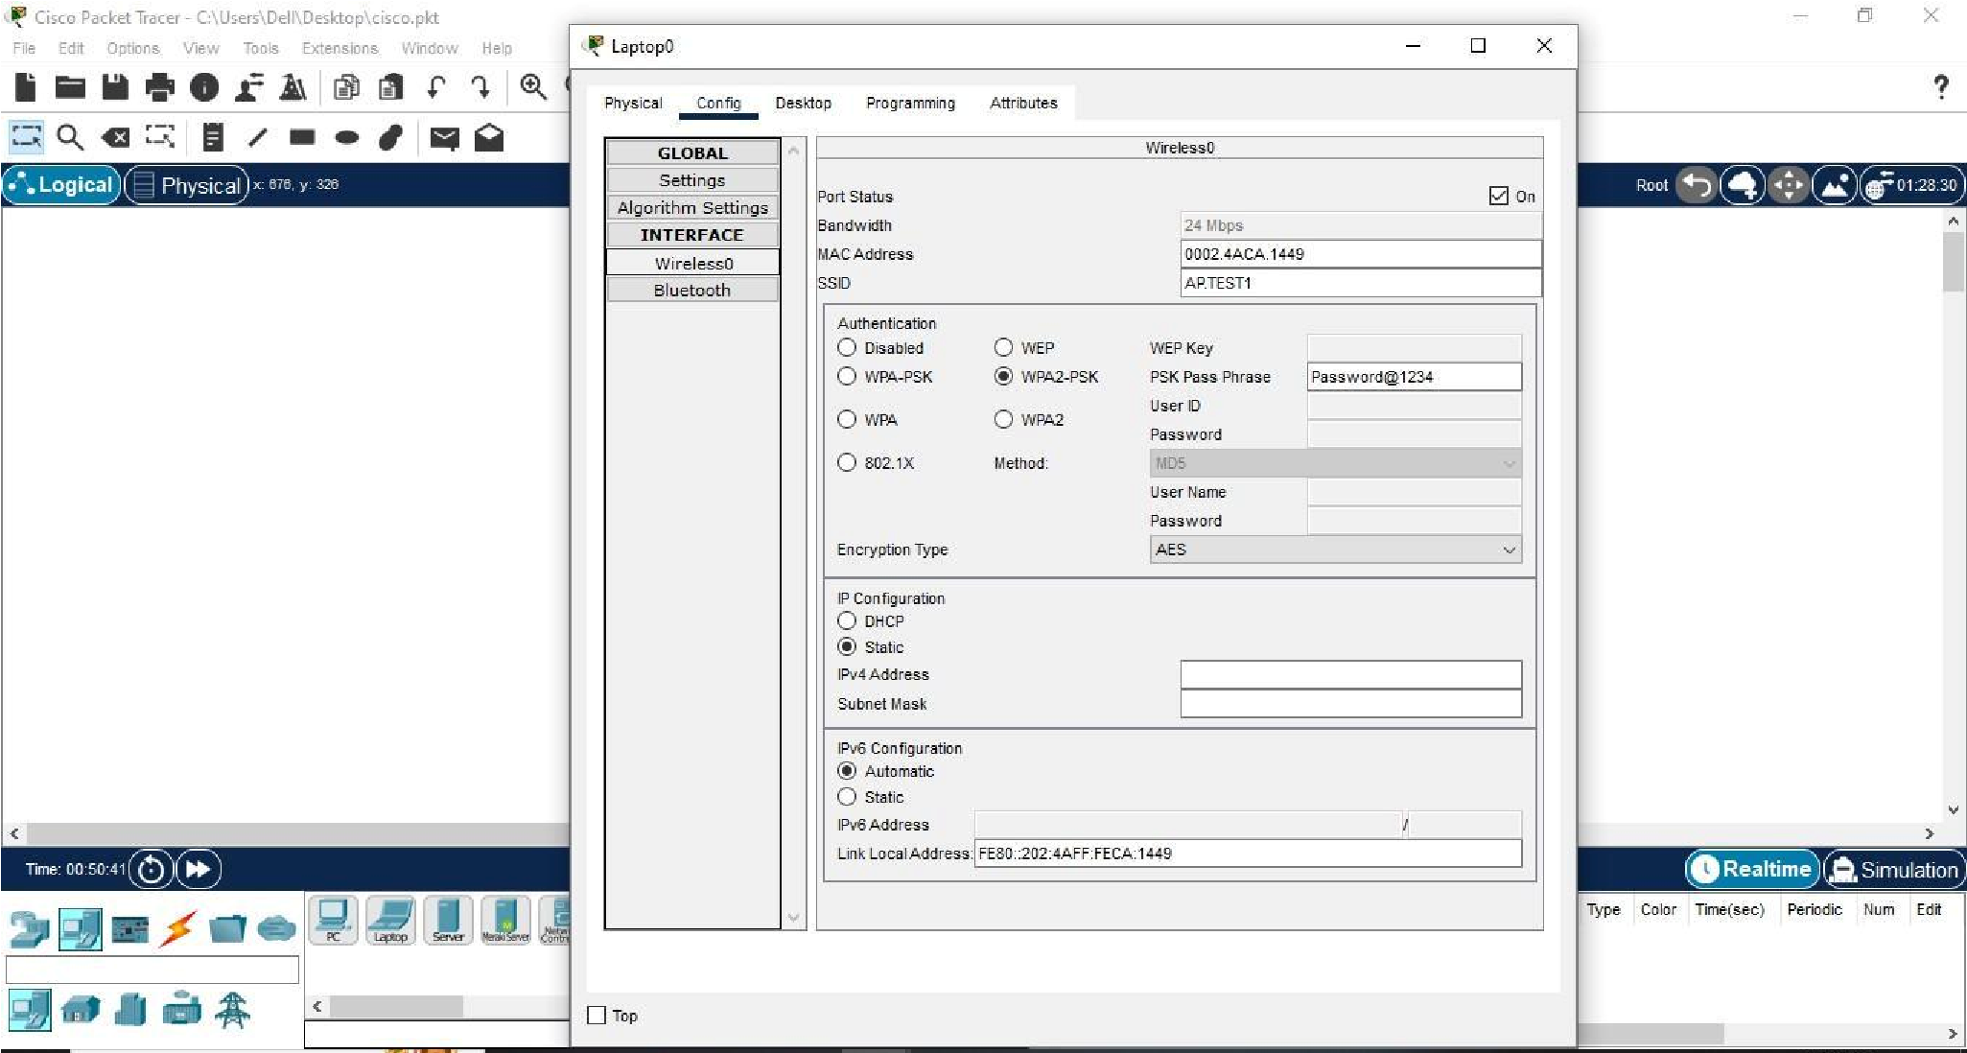

Q.2: How to Perform configuration of wireless access point. (Attach all screenshots)
Ans Step 1: Open the access point’s setup page
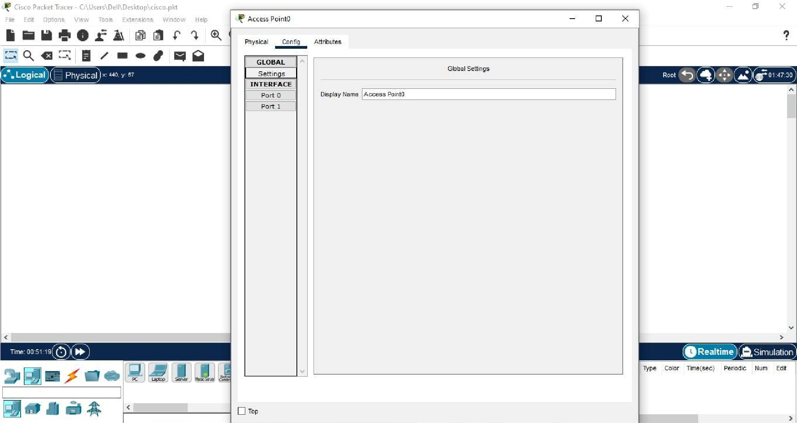
Step 2 : Click on Config and goto port 1.
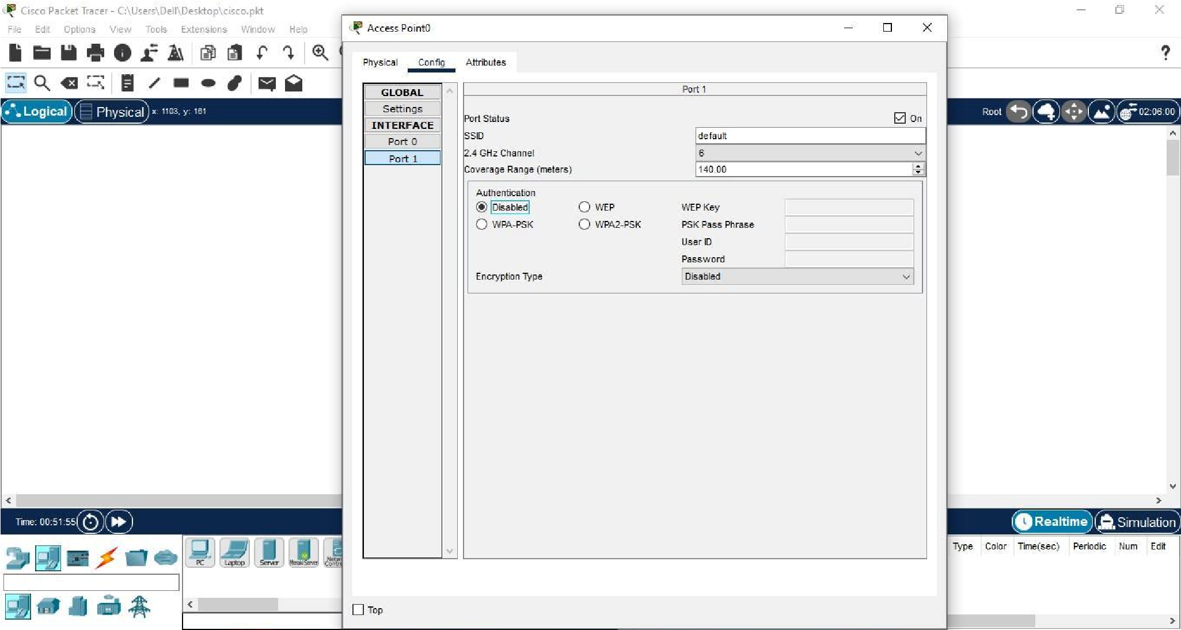
Step 3: Enter the Network Name (SSID) and Click Wireless Security and select your desired Security Mode
WPA2-PSK
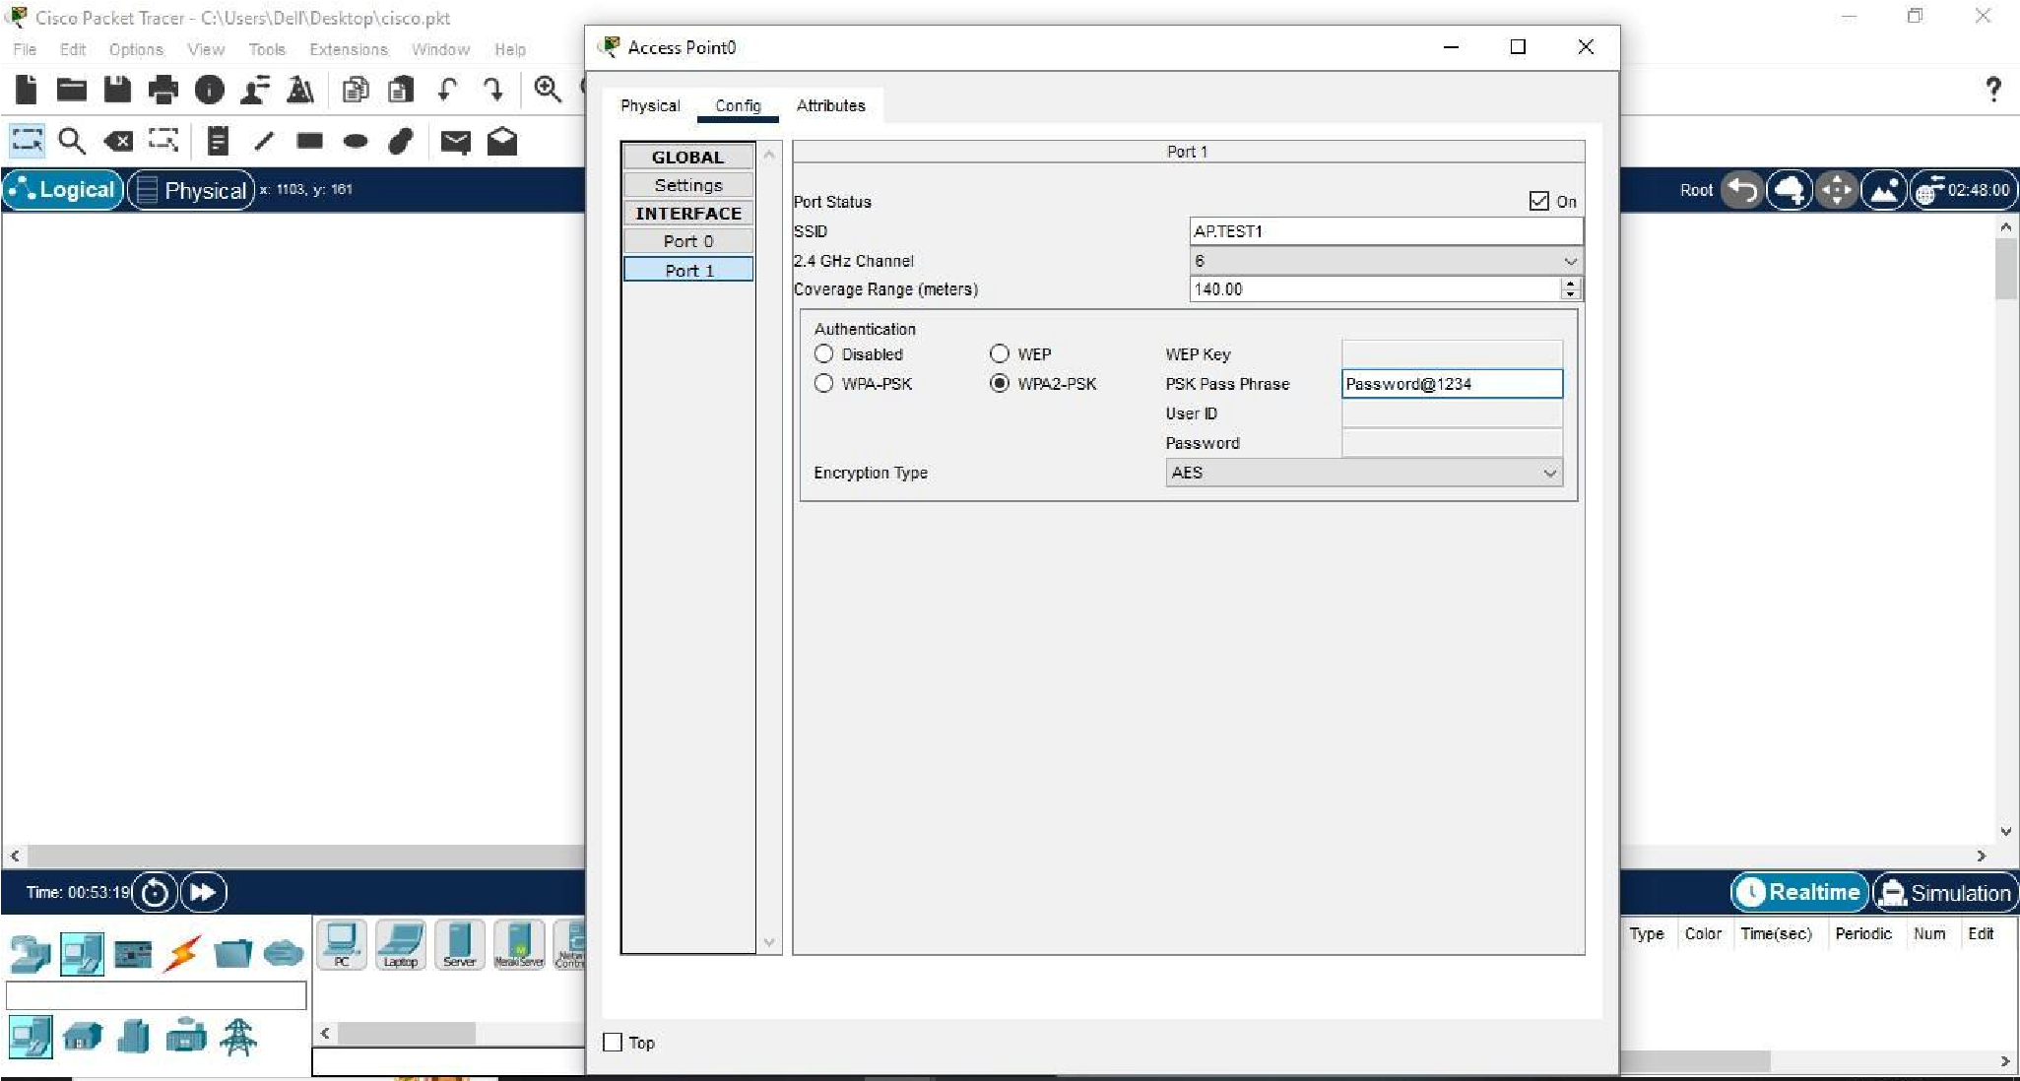
Your access point is now successfully configured.

Q.3: How adhoc Wireless LAN will be created?
Ans Creating an ad-hoc wireless LAN involves setting up a wireless network without the need for a centralized access point. Ad-hoc mode is a peer-to-peer networking mode where wireless devices communicate directly with each other rather than through a central router or access point. Here's a general guide on how to create an ad-hoc wireless LAN:
For Windows:
- Open Network and Sharing Center:
● Open the "Control Panel." ● Go to "Network and Sharing Center."
- Set Up a New Connection:
    - Click on "Set up a new connection or network."
    - Choose "Set up a wireless ad-hoc (computer-to-computer) network."
- Configure Network Settings:
    - Enter a Network name (SSID) for your ad-hoc network.
    - Choose a Security type and set a Security key (password).
    - Check the box for "Save this network."
- Start the Ad-hoc Network:
    - Click "Next" and then "Close" to finish the setup.
Your computer will start broadcasting the ad-hoc network.

Q.4: What is difference between WLAN and WiMax ?
Characteristics | WLAN | WiMax
Standards | IEEE 802.11 family (e.g.,  802.11a, 802.11n) | IEEE 802.16 (e.g.,  802.16d, 802.16e)
Deployment | Local area networking | Wide-area coverage
Frequency Bands | 2.4 GHz, 5 GHz | Dependent on a specific implementation
Data Transfer Rates | Up to several hundred Mbps | Up to several hundred Mbps
Security | Utilizes security protocols like WEP, WPA, and  WPA2. | Implements security measures for secure communiation.

B.2 Conclusion:

(Students must write the conclusion as per the attainment of individual outcome listed above and learning/observation)
In conclusion, the set up and configuration of a Wireless Access Point involve a combination of technical knowledge, strategic planning, and ongoing maintenance. A well-configured WAP ensures a secure, reliable, and efficient wireless network that meets the needs of users and devices within its coverage area. Regular monitoring and adaptation to changing requirements contribute to the long-term success of the wireless infrastructure.

